India tour 14-30 November 2018
Hotels
Itinerary:-
From the Anglican Tours India tour booklet the hotels listed for the tour are as follows:-
Day 2 (after arrival in New Delhi) – Oberoi Maidens, 7 Sham Nath Marg, Prema Kunj, Civil Lines, New Delhi 110054.

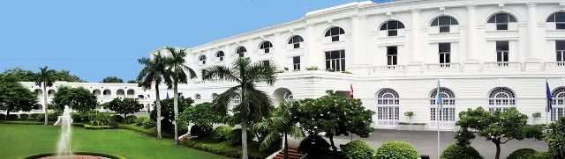

This hotel was booked for 2 nights stay in Delhi. Alan was allocated room 215, a large bedroom with adjoining bathroom. It was a probable 3-4 star rating hotel with long passageways to rooms and sadly in need of some repairs.
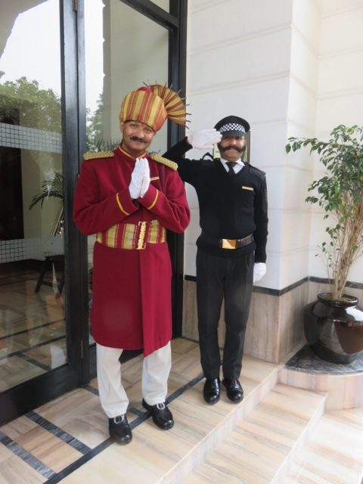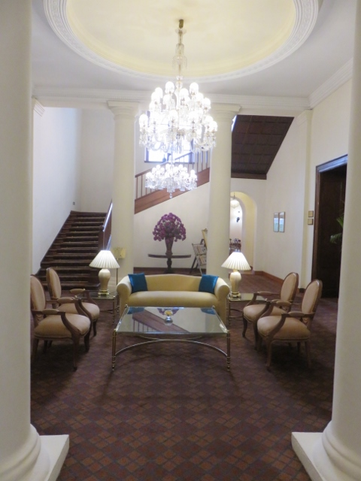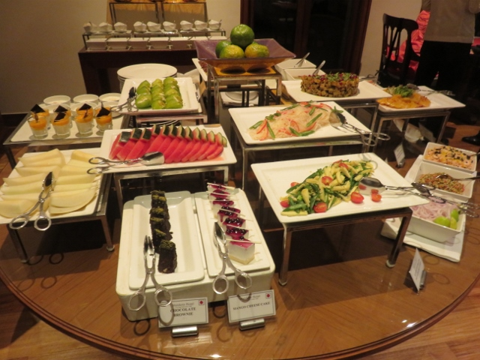
Arrival greetings at front door. Lobby with door to dining room at back. Breakfast selection of fruits.
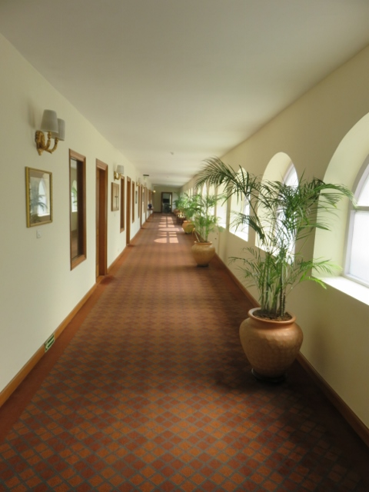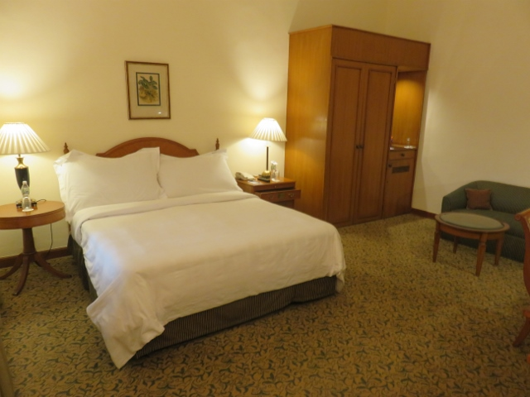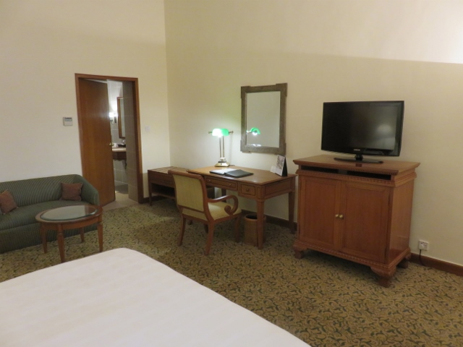
Hallway to Alan’s room, 3rd on left. Room 215 basic layout. Bathroom through door at back of room.

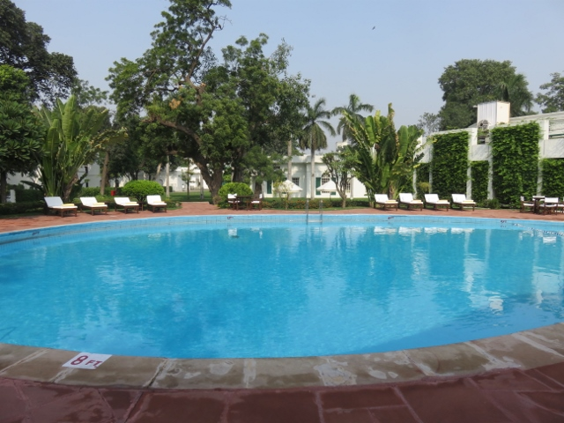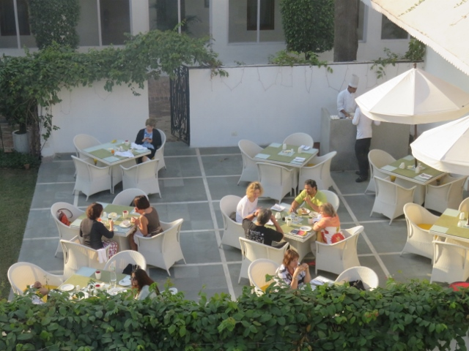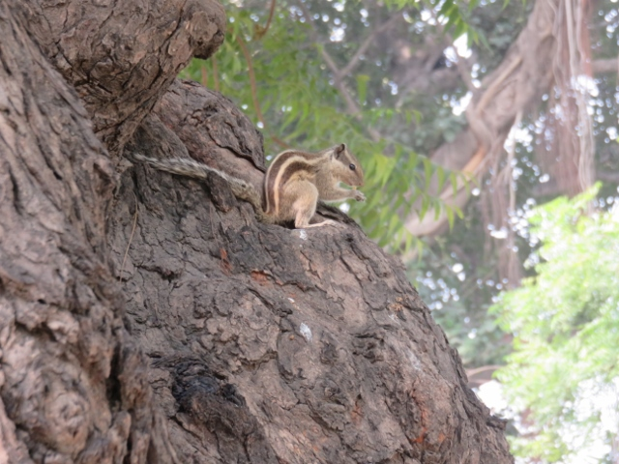
Hotel swimming pool. Courtyard dining for breakfast Resident squirrel on garden tree trunk.
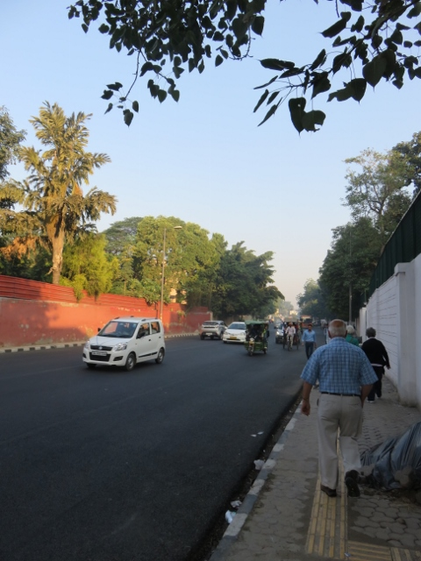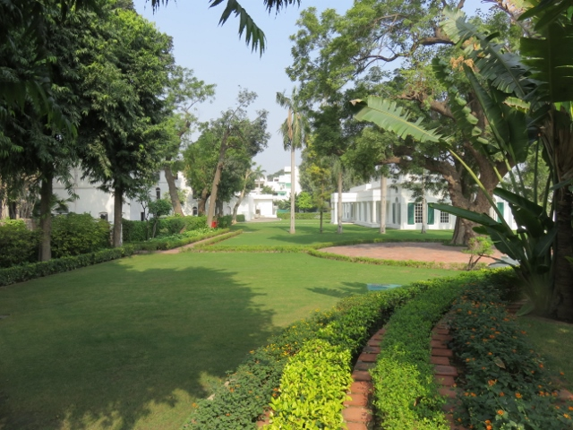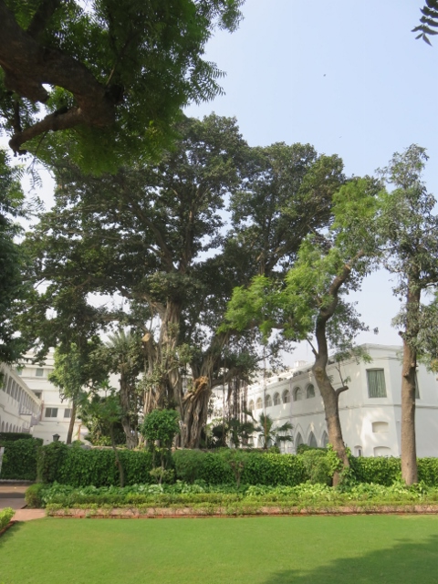
Walled roads outside hotel. Hotel manicured gardens and lawns More trees and lawns.
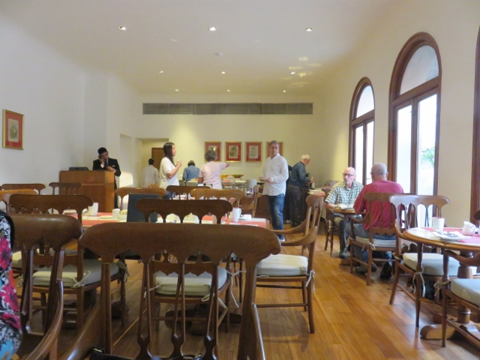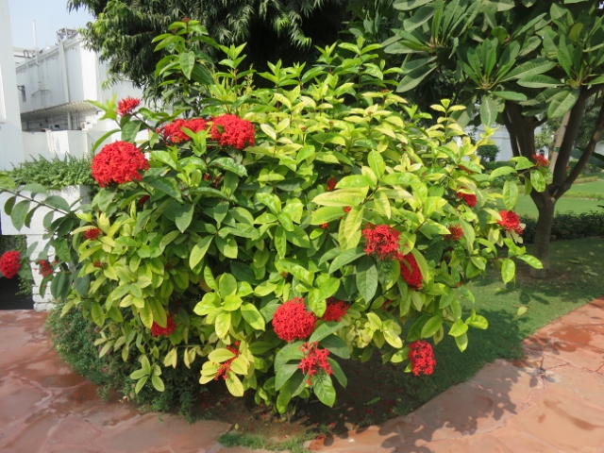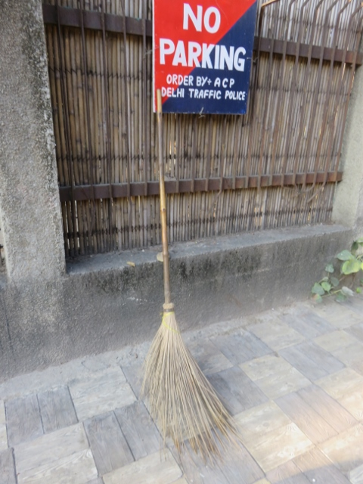
Dining room Garden flowering bush. Method of street cleaning.
Being the first hotel to stay on this tour the expectations were not very high, particularly as the building was located north of the Delhi city proper. The food was good with a diversity of choices from western style to Indian spice dishes at both breakfast and dinner.
The traffic encountered from the airport to the hotel was horrendous. A pleather of vehicles of all sizes, tuk-tuks, rick-shaws, moto-bikes, bicycles, cars and trucks all tooting their horns endlessly. The tour bus driver has to be commended for getting the tour members safely through the chaos. Some observations on the drive to the hotel included sight of small monkeys roaming near a walled park with wild hogs nearby feeding on rubbish. Welcome to Incredible India!

